SALES ANALYSIS PROJECT

Terminal:
mysql --version, output -> mysql Ver 14.14 Distrib 5.7.24, for osx10.9 (x86_64) using EditLine wrapper
which sql, output -> /opt/anaconda3/bin/mysql
which psql, output -> psql not found
which sqlite3, output -> /opt/anaconda3/bin/sqlite3
mkdir sales_analysis, creates a folder named ‘sales_analysis’ in your current location (Home)
cd sales_analysis, going inside the folder ‘sales_analysis’
pwd, print working directory (shows current location)

mv ~/sales_analysis ~/Desktop/, moving ‘sales_analysis’ to desktop.
mkdir data sql python output, creating 4 folders named ‘data’, ‘sql’, ‘python’ and ‘output’ in the ‘sales_analysis’ folder.
ls, lists everything inside the folder
mv ~/Downloads/SampleSuperstore.csv data/, moving SampleSuperstore.csv from downloads to ‘data’ in ‘sales_analysis’ folder
sqlite3 sales.db, creates a file named ‘sales.db’ in SQLite
sqlite>, means we are in sqlite
.databases, shows databases sqlite is connected to
main: /Users/swapnilchhabra/Desktop/sales_analysis/sales.db r/w, means everything we do will be saved under sales.db and SQLite has read/write access
.mode csv, tells sql how to read or display data in CSV format
.import data/SampleSuperstore.csv temp_check, importing our data to a temp table called ‘temp_check’
.tables, list all the tables that exist.
PRAGMA table_info(temp_check);, this will list all column names from the CSV
output -> 0|Ship Mode,Segment,Country,City,State,Postal Code,Region,Category,Sub-Category,Sales,Quantity,Discount,Profit|TEXT|0||0, sqlite guessed everything as text because csv files are text based. For real analysis, this is not ideal so we are gonna delete this table and create a new one with correct data types.
DROP TABLE temp_check;, drop temp table (temp_check)
CREATE TABLE ss_sales ( ship_mode TEXT, segment TEXT, country TEXT, city TEXT, state TEXT, postal_code TEXT, region TEXT, category TEXT, sub_category TEXT, sales REAL, quantity INTEGER, discount REAL, profit REAL);, this will create a proper table with correct data types but the I was not able to import csv data to the real table so decided to switch to python for loading the file to sqlite.

Cursor code to load the CSV file to SQLite3:
import pandas as pd #importing pandas to work with tables
import sqlite3 #importing a tool to work with SQLite database

#path to CSV file
csv_path = "data/SampleSuperstore.csv"

#read CSV using pandas
df = pd.read_csv(csv_path)

#quick sanity check
print("Shape:", df.shape) #gives total rows and columns
print(df.head()) #shows first 5 rows by default

#connect to SQLite databasex
conn = sqlite3.connect("sales.db") #if sales.db exists, open it

#load data into SQLite
#ETL -> EXTRACT - CSV, TRANSFORM - PANDAS, LOAD - SQLite
df.to_sql("ss_sales", conn, if_exists="replace", index=False)

#close connection
conn.close()

print("Data successfully loaded into SQLite!")

Now coming back to SQL for further analysis:
Q1: Total Sales & Profit?
A1: SELECT SUM(Sales) AS total_sales,
SUM(Profit) AS total_profit
FROM ss_sales;
Output: total_sales = 2297200.86029996 | total_profit = 286397.021700001

Q2: Total Sales by Region?
A1: SELECT Region, ROUND(SUM(Sales), 2) AS total_sales
FROM ss_sales
GROUP BY Region
ORDER BY total_sales DESC;
Output: West|725457.82
East|678781.24
Central|501239.89
South|391721.91
Q3: Top 5 States by Sales
A3: SELECT State, ROUND(SUM(Sales), 2) AS total_sales
FROM ss_sales
GROUP BY State
ORDER BY total_sales DESC
LIMIT 5;
Output: California|457687.63
New York|310876.27
Texas|170188.05
Washington|138641.27
Pennsylvania|116511.91

Q4: Loss-making orders
A3: SELECT Category, "Sub-Category", ROUND(SUM(Profit), 2) AS total_profit
FROM ss_sales
GROUP BY Category, "Sub-Category"
HAVING SUM(Profit) < 0
ORDER BY total_profit;
Output: Furniture|Tables|-17725.48
Furniture|Bookcases|-3472.56
Office Supplies|Supplies|-1189.1

Cursor code to read SQLite data into Python:
import pandas as pd
import sqlite3

#connect to SQLite database
conn = sqlite3.connect("sales.db")

#read data from SQLite table
df = pd.read_sql("SELECT * FROM ss_sales", conn)

conn.close()

#quick sanity check
print("Shape:", df.shape)
print(df.head())

Analysis using Python:

Q1: how much total profit did each category make?
A1: category_profit = (df.groupby("Category")["Profit"]
.sum()
.sort_values())
print("\nCategory-Level Profit")
print(category_profit)
output : Category-Level Profit Category
Category
Furniture 18451.2728
Office Supplies 122490.8008
Technology 145454.9481
Name: Profit, dtype: float64

Q2: within each category, which sub-categories make or lose money?
A2: subcat_profit = (df.groupby(["Category", "Sub-Category"])["Profit"]
.sum()
.sort_values())
print("\nSub-Category Level Profit")
print(subcat_profit)
output : Sub-Category Level Profit
Category Sub-Category
Furniture Tables -17725.4811
Bookcases -3472.5560
Office Supplies Supplies -1189.0995
Fasteners 949.5182
Technology Machines 3384.7569
Office Supplies Labels 5546.2540
Art 6527.7870
Envelopes 6964.1767
Furniture Furnishings 13059.1436
Office Supplies Appliances 18138.0054
Storage 21278.8264
Furniture Chairs 26590.1663
Office Supplies Binders 30221.7633
Paper 34053.5693
Technology Accessories 41936.6357
Phones 44515.7306
Copiers 55617.8249
Name: Profit, dtype: float64

Q3: for each discount %, what is the average profit?
A3: discount_profit = (df.groupby("Discount")["Profit"]
.mean()
.reset_index()
.sort_index())
print("\nAverage Profit by Discount")
print(discount_profit)
output : Average Profit by Discount
Discount Profit
0 0.00 66.900292
1 0.10 96.055074
2 0.15 27.288298
3 0.20 24.702572
4 0.30 -45.679636
5 0.32 -88.560656
6 0.40 -111.927429
7 0.45 -226.646464
8 0.50 -310.703456
9 0.60 -43.077212
10 0.70 -95.874060
11 0.80 -101.796797

INSIGHTS COVERED:
1) The furniture category underperforms due to losses in Tables and Bookcases.
2) Discounts above 40% consistently result in negative average profit.
3) Technology category drives profitability, especially Phones and Copiers.

Plots:

- Plot profit by category:

#Plot profit by category
category_profit.plot(kind="bar", title="Total Profit by Category")
plt.ylabel("Profit")
plt.tight_layout()
plt.show()

Bar Chart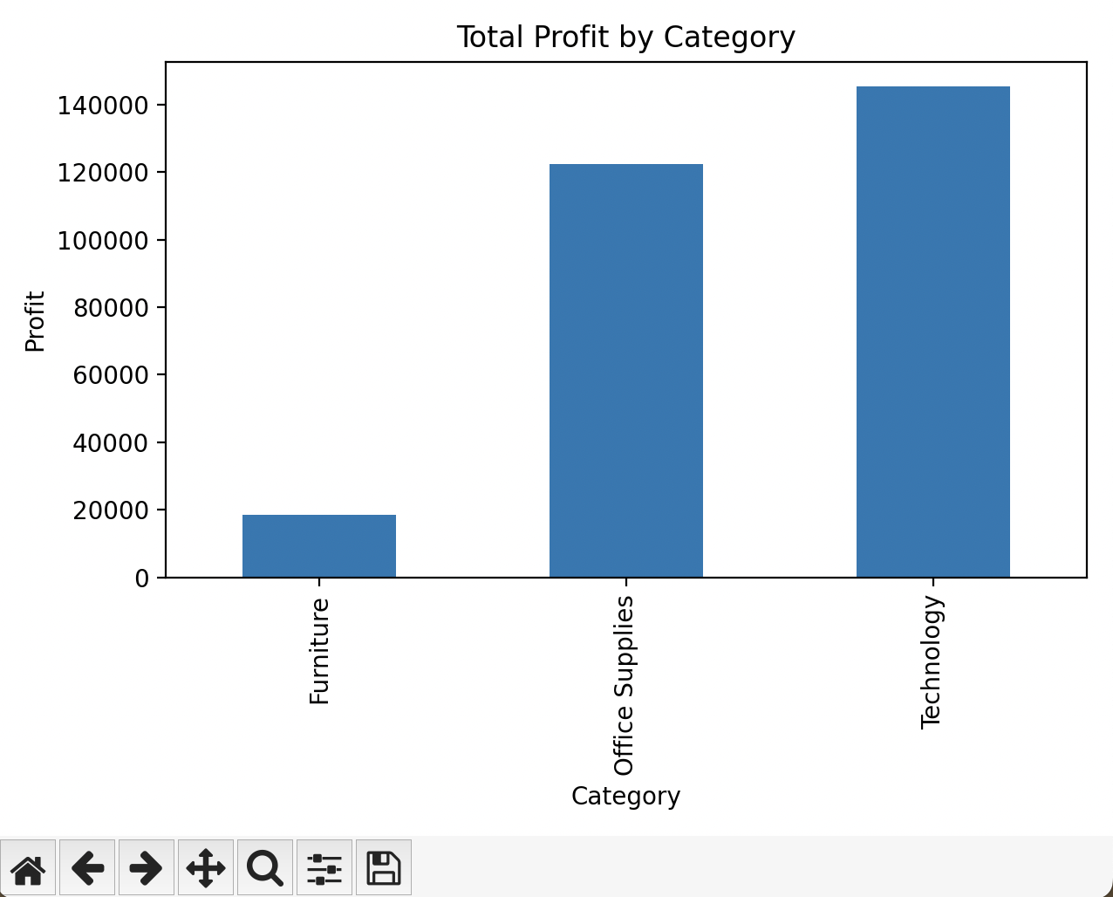

- Plot profit/loss by sub-category:

#Plot profit by sub-category
subcat_profit.plot(kind="bar", title="Total Profit by Sub-Category")
plt.ylabel("Profit/Loss")
plt.tight_layout()
plt.show()

Bar Chart
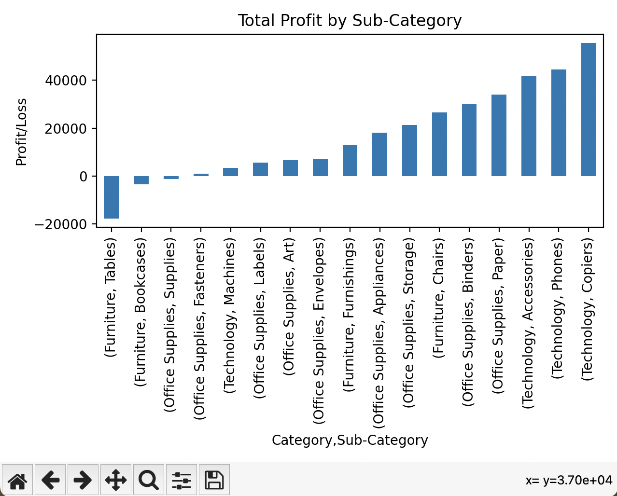

- Which specific sub-categories are causing losses?

loss_subcats = subcat_profit[subcat_profit < 0].head(10)

loss_subcats.plot(kind="barh", title="Top 10 Loss-Making Sub-Categories")
plt.xlabel("Total Profit")
plt.tight_layout()
plt.show()

Horizontal Bar Chart
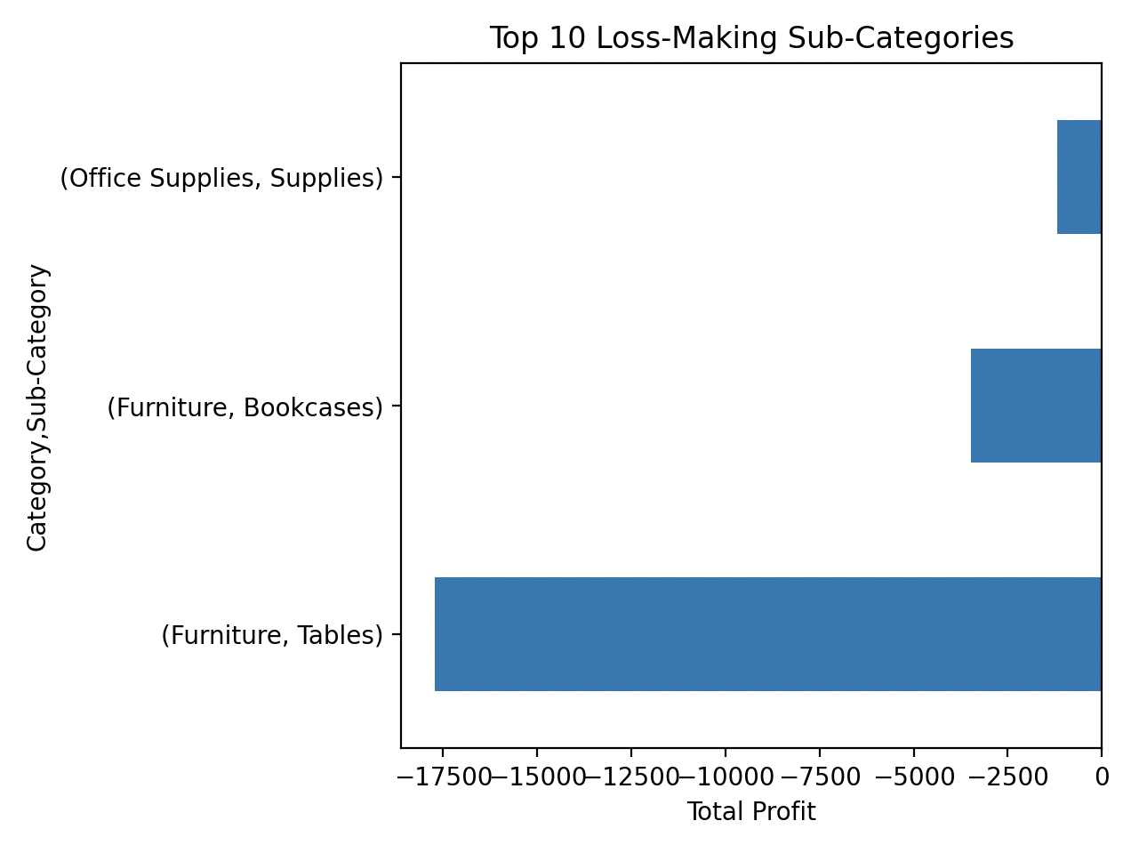

- At what discount level does profit start going negative?

plt.plot(discount_profit["Discount"], discount_profit["Profit"], marker="o")

plt.axhline(0) # break-even line
plt.title("Average Profit by Discount Level")
plt.xlabel("Discount")
plt.ylabel("Average Profit")
plt.tight_layout()
plt.show()

Line Chart
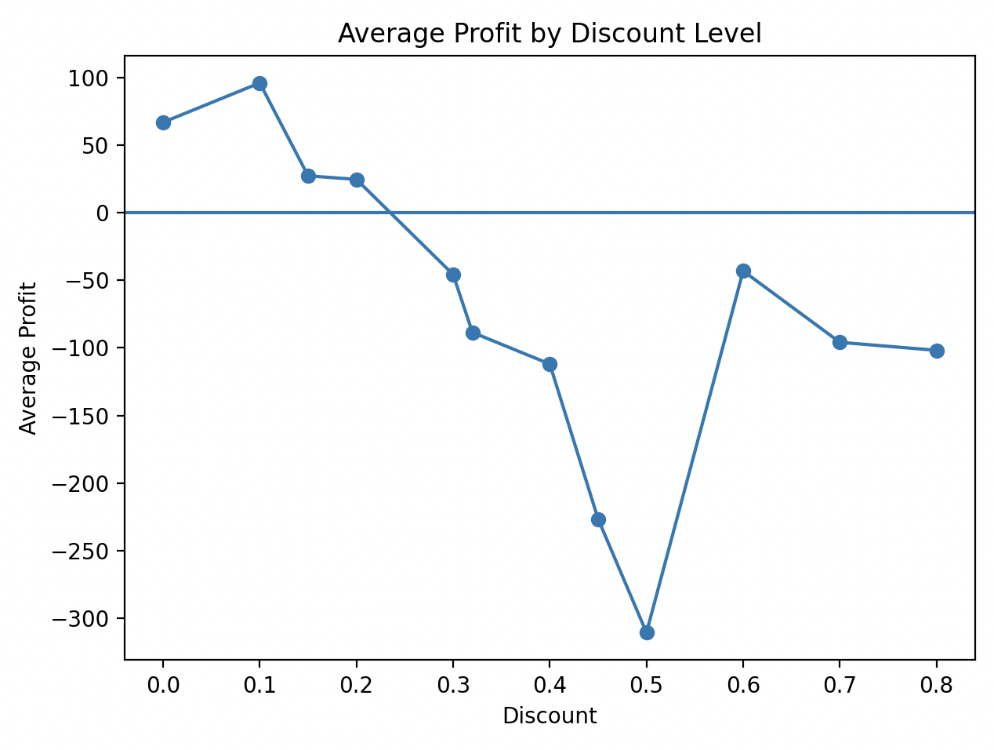

- Do higher sales always mean higher profit?

plt.scatter(df["Sales"], df["Profit"], alpha=0.3)
plt.axhline(0)
plt.title("Sales vs Profit")
plt.xlabel("Sales")
plt.ylabel("Profit")
plt.tight_layout()
plt.show()

Scatterplot:
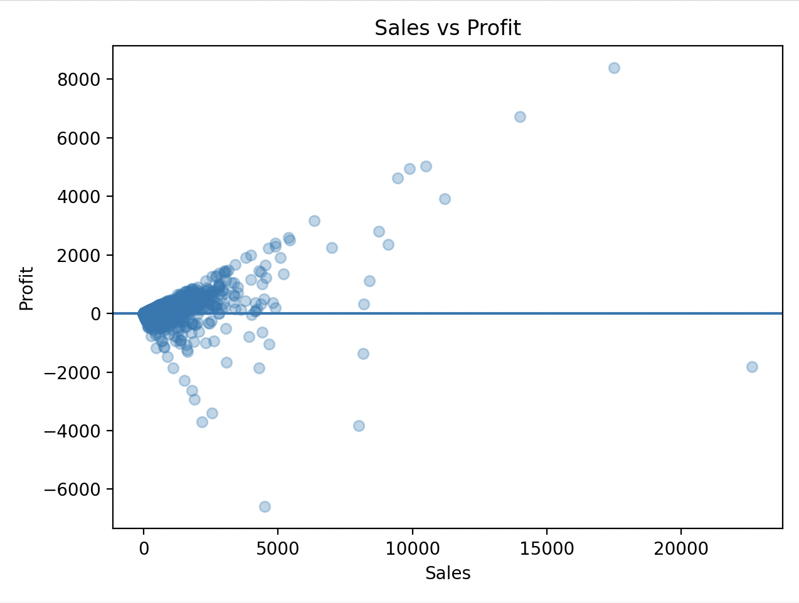

- Are most orders profitable or loss-making?

plt.hist(df["Profit"], bins=50)
plt.axvline(0)
plt.title("Distribution of Profit per Order")
plt.xlabel("Profit")
plt.ylabel("Number of Orders")
plt.tight_layout()
plt.show()

Histogram
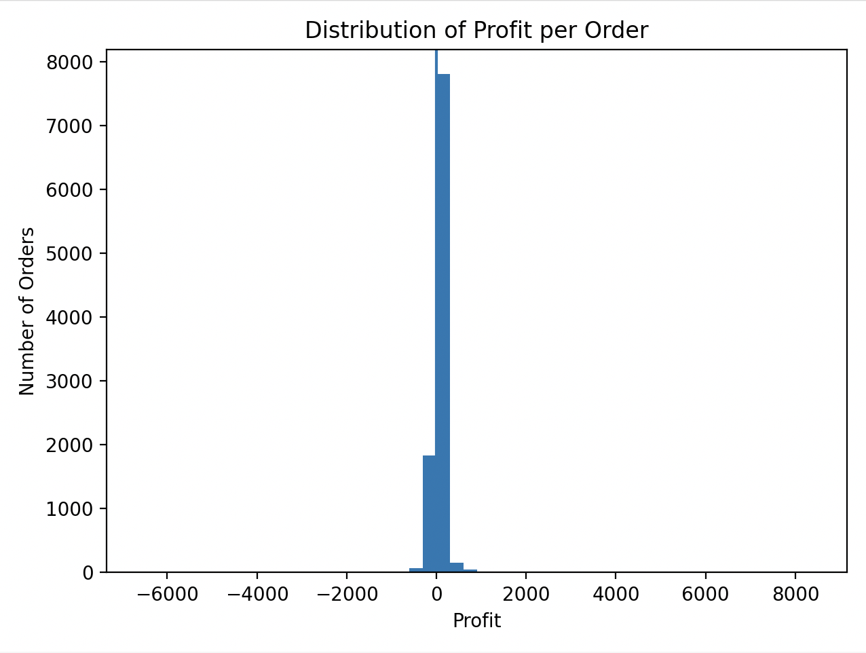

Business Insights from the Analysis

- Revenue alone doesn’t guarantee profitability. Some categories generate sales but destroy margin.
  - some type of products make good money, some barely make money and some actually lose money or
  - just because we sell a lot of something doesn’t mean it’s good for business.
- Losses in Furniture are concentrated in specific sub-categories, not the entire category.
  - furniture as a whole is not terrible, but some furniture items are hurting the business badly.
- Higher Discounts do not increase profitability, it destroys it.
  - giving too much discount is costing the company money or
  - we are cutting prices so much that we’re selling products at a loss.
- The Company is “buying revenue” by sacrificing margin.
  - selling more items doesn’t automatically mean the company earns more money or
  - we are chasing sales no instead of actual profit
- The Business does not have a systematic problem, it has targeted operational issues.
  - the whole business is not broken.
  - if we fix a few problem areas, profits can improve a lot.

